* 1. **Number**

**Name __________ class ___________**

1. Record the total time to complete the assignment.
2. X = 10110010.
   1. The contents of X represent an unsigned binary integer.

Convert the value in X into denary.

* 1. The contents of X represent an unsigned binary integer.

Convert the value in X into hexadecimal.

* 1. The contents of X represent a two’s complement binary integer.

Convert the value in X into denary.

1. **(a)** Each of the following bytes represents an integer in two’s complement form.

State the denary value.

0111 0111:

1000 1000:

**(i)** Express the following integer in two’s complement form.

-17

1. State in denary, the range of integer values that it is possible to represent in two’s complement integers using a single byte.

Lowest value:

Highest value:

**(b) (i)** Convert the following denary integer into Binary Coded Decimal (BCD).

653

**(ii)** A 3-digit BCD representation has been incorrectly copied. It is shown as:

0 1 0 0 1 1 1 0 0 0 1 0

State how you can recognize that this is not a valid BCD representation.

**(iii)** Describe a practical application where BCD is used.

1. **(a) (i)** Convert the denary number 46 to an 8-bit binary integer.

**(ii)** Convert the denary integer – 46 to an 8-bit two’s complement form.

**(iii)** Convert the denary number 46 into hexadecimal.

**(b)** Binary Coded Decimal (BCD) is another way of representing numbers.

**(i)** Describe how denary integers larger than 9 can be converted into BCD. Give an example in your answer.

**(ii)** Describe how an 8-bit BCD representation can be converted into a denary integer. Give an example in your answer.

1. Hexadecimal, Binary Coded Decimal (BCD) and binary values are shown below.

Draw a line to link each value to its correct denary value.

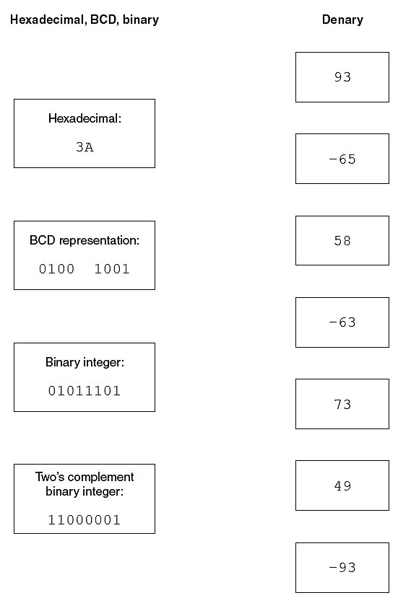

1. **(a)** Convert the following denary integer into 8-bit binary.

55

**(b)** Convert the following Binary Coded Decimal (BCD) number into denary.

100100111000

**(c)** Convert the following denary integer into 8-bit two’s complement.

-102

**(d)** Convert the following hexadecimal number into denary and binary.

4E

FA

**(e)** Convert the following denary number into hexadecimal. Show the process.

198

1. **(a)** Describe a use of BCD number representation.

**(b)** Translate the 10011100 into hexadecimal

Translate the 11010011 into hexadecimal

Translate 101 (denary) into hexadecimal.

Translate 64 (denary) into hexadecimal.

Translate 96 (hexadecimal) into denary

Translate the 75 (hexadecimal) into denary.

Translate the 30 (hexadecimal) into denary.

1. **(a)** A particular computer stores numbers as 8 bit, two’s complement, binary numbers. 11011101 and 11010010 are two numbers stored in the computer. Add the two binary values together and show your process.

**(b)** Why we use BCD arithmetic?

**(c)** Show the process of 123+89 using the BCD arithmetic.